Jacob Abts

CS255

October 21, 2022

# CS 255 System Design Document Template

## UML Diagrams

### UML Use Case Diagram

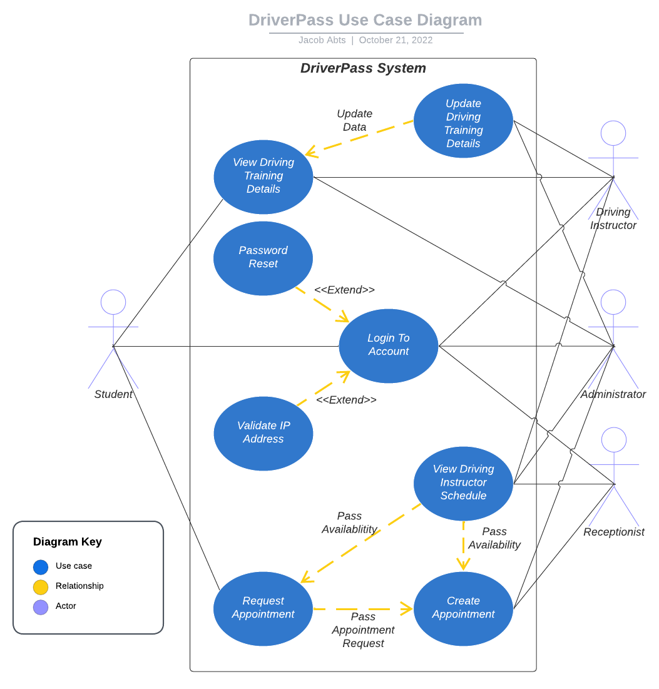

### UML Activity Diagrams

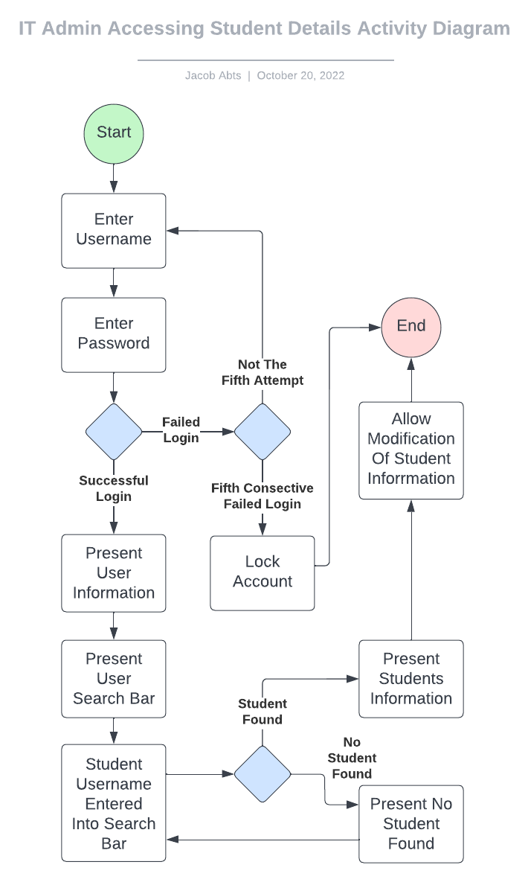

### UML Sequence Diagram

### UML Class Diagram

## Technical Requirements

The minimal hardware requirements due the current recommended system to be driven off the AWS Cloud Services are just a server to host the domain and a server to store the data. The software requirements would be a Java development environment. The tools required are several AWS Accounts that will serve as the primary identification and management points for the subservices. The infrastructure will likely use Rust to host the front-end access points, using an AWS Lambda back-end to handle the requests and business logic, and that will send requests to the server running MongoDB databases.

Due to there being no current infrastructure for the project, the foundation for modifying the project and connecting all the subservices would require a significant amount of time to develop. Since the system would be hosted through cloud services, a drawback will be that the system will draw money as used. Since there is to direct access to the servers, all data to and from a subservice will either be on an isolated network or encrypted adding to the complexity of the project.